ID No: | 56984 | Date: | 11-10-2024
Patient Name | Md. Nur Islam | Age: | 33 Years | Sex: Male
Ref By | Self

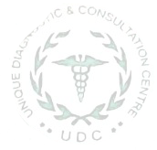

SEROLOGY REPORT

Name of test | Result
Blood Group | ABO | “O” (+Ve)
Blood Group | Rh Factor | Positive (+Ve)

